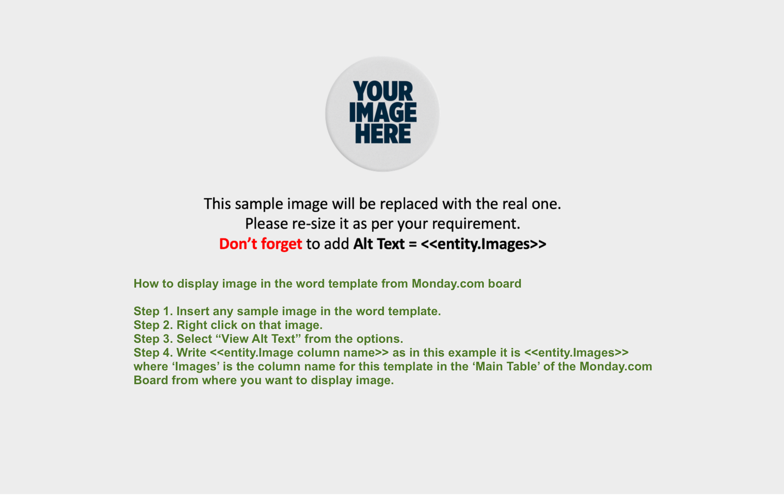

<<entity.Property Address>> |  | <<entity.Listing Type>>
<<entity.Price>> | This immaculate <<entity.Property Type>> <<entity.Short Description1>>  <<entity.Short Description2>>  The <<entity.Property Type>> features:  - <<entity.Bedrooms>> bedrooms  - <<entity.Bathrooms>> bathrooms and toilets  - <<entity.Feature1>>  - <<entity.Feature2>>  - <<entity.Feature3>>  - <<entity.Feature4>>  - Land size: <<entity.SQFT>> sqft approx.  - Orientation: <<entity.Property Orientation>>
<<entity.Bedrooms>>
<<entity.Bathrooms>>
<<entity.Land Size(Sqm)>> m²


ABC Realty Group

